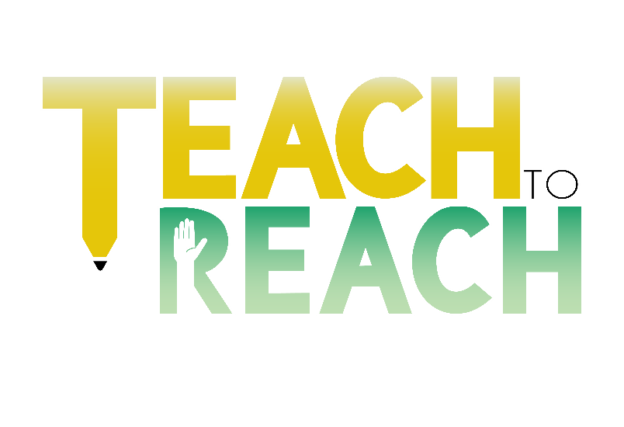Date

City, State, Zip

Name

Address

Hello,

Far too often do we see that young adolescents are left behind but Teach to Reach Inc. has made a promise to be the village that will continuously uplift our youth. We are a non-profit organization whose responsibility is to ensure that no child is left without guidance. In fact, our mission is to promote education, respect, and self-awareness to inner-city youth by providing enriching opportunities and powerful relationships to ultimately build leaders that are capable of exceeding expectations in the 21st century.

Teach to Reach strives to be a strong member of the community. We are writing to you because we are in need of funding as well as donor support.

Providing a small donation can help us accomplish the task of pouring into our inner-city youth.

Your support is the key to helping us accomplish our goals.

Our vision is to create leaders of tomorrow by focusing on the impact they make today.

Your donation will aid in providing products and services for back to school drives, community service events, etc. to promote said leaders.

If we can teach one young boy or girl to make conscious decisions, we have done our job. It takes one child to change the world and we want to provide a safe place for that child to cultivate.

Thank you in advance for your contribution. You have no idea how much it means to have your support.

The attached donation form can be used to give your support.

Thank you again!

Sincerely,

Teach to Reach Inc.

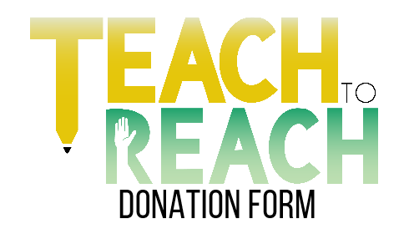

**Please consider donating to our non-profit. Your generosity makes it possible to continue our vision of creating leaders of tomorrow by focusing on the impact they make today.**

|  |  |
| --- | --- |
| Business Name (if applicable) |  |

|  |  |  |  |
| --- | --- | --- | --- |
| Contact Name (Last, First, M.I) |  | City, State, Zip |  |

|  |  |  |  |  |  |  |  |
| --- | --- | --- | --- | --- | --- | --- | --- |
| Phone |  | | Email |  | Social Media | |  |
| Website (if applicable) | |  | | | |

**Please Indicate Below Whether You Would Like to Donate a Monetary Gift, Product, or Service**

**Cash** **Product** **Service**

|  |  |
| --- | --- |
| Amount/Description |  |

Microsoft Office Signature Line...

**Get in touch with us:**

**Phone**: (770) 502-5557

**Email**: teaching2reach@gmail.com

**Instagram**: weteachwereach

Service

Product

Money